Project 2:

Project TWO of the series, where you will learn **how to store your web application's source code in a repository.**

Step 1: **Create a Repository in AWS CodeCommit**

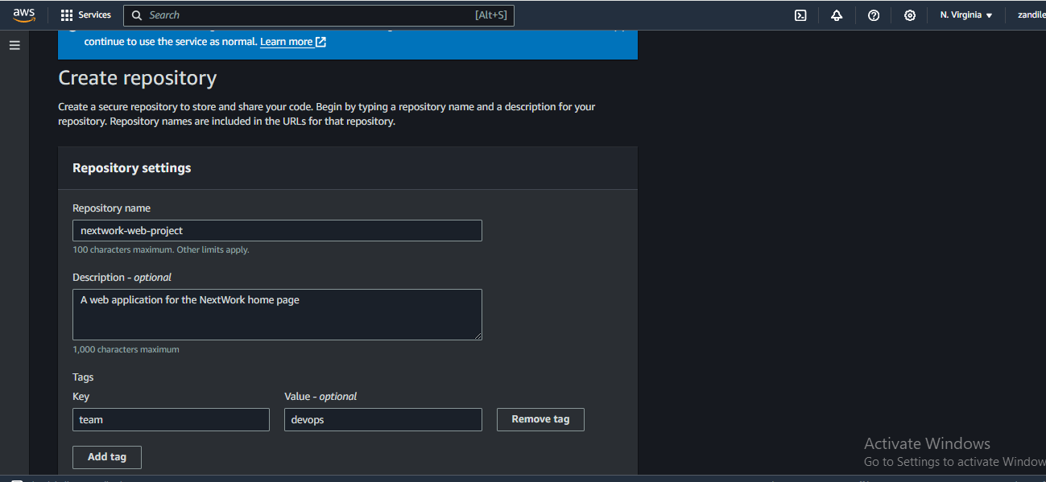

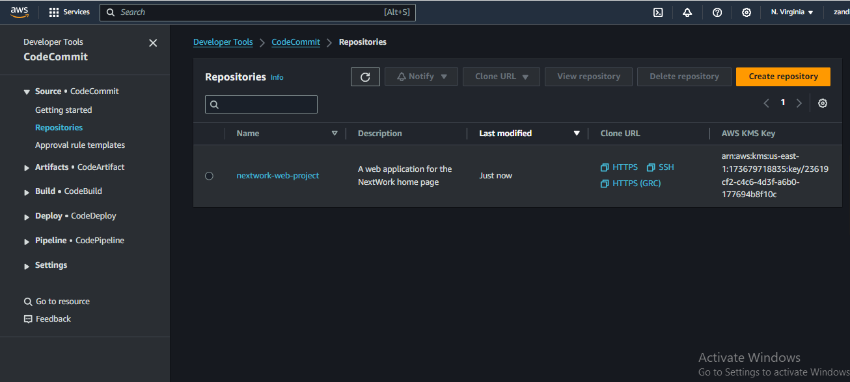

Step 2: **initialize a new Git repository from Cloud9**



Step 3: **Setting the remote origin to the CodeCommit repo**



See the files from Cloud9 in the CodeCommit repo

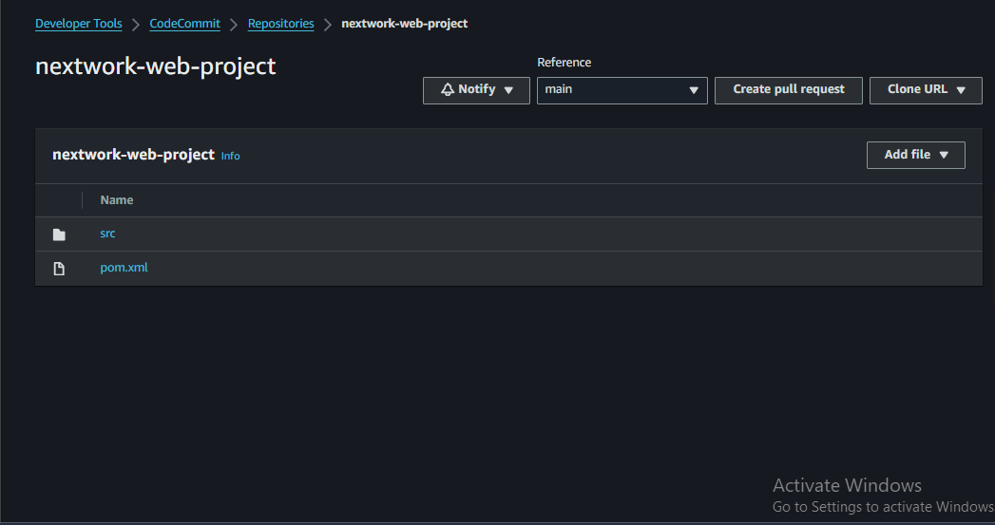

Step 4: **Changing the file in Cloud9**

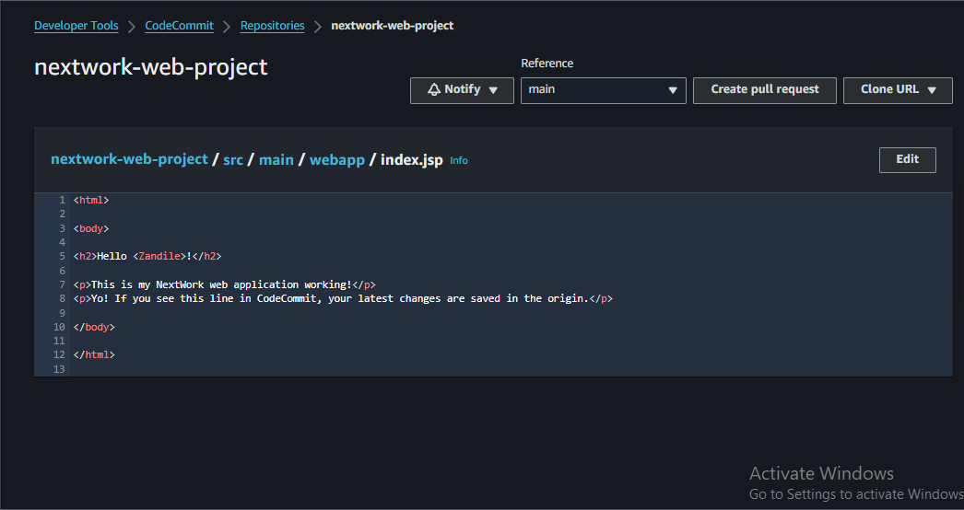

Lesson:

Today you've learnt how to:

1. ⚙️ **Set up a CodeCommit Repository:** You created a new repository in AWS CodeCommit to securely store and manage the source code for your Java web app.
2. ☁️ **Configure Git in Cloud9:** You established your Git identity with your username and email, so your changes to the repository are properly attributed to you.
3. 📂 **Initialize and Configure Your Local Repository:** In the Cloud9 environment, you initialized a new Git repository. You set up your CodeCommit repository as the remote origin, preparing the path to synchronize your local and remote repositories.
4. 🫸 **Make Your First Commit and Push:** You added all your files to the staging area, committed them with a message marking the "Initial commit", and pushed these changes to the main branch of your CodeCommit repository, making your code available in the cloud.
5. 🗂️ **Understand and Organize Your Project Structure:** You've learned about the essential files in your repository, such as the src directory for your source code, and pom.xml file for managing your Maven project's dependencies and settings.